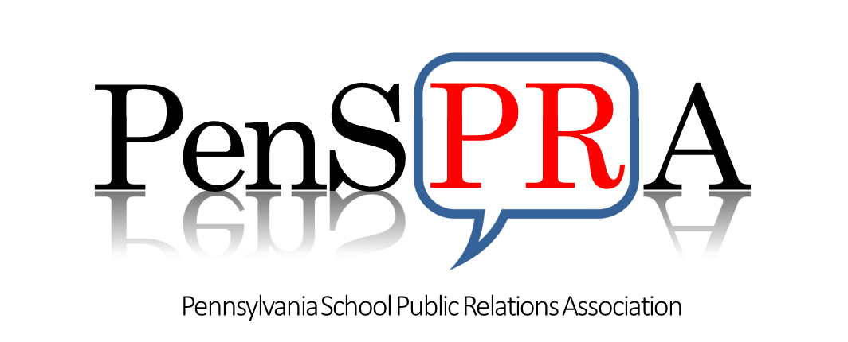
Strategic Plan
2022 - 2024

Strategic Goal 1: Membership | Strategic Goal 2: Relationships | Strategic Goal 3: Leadership | Strategic Goal 4: Stewardship
Expand membership experience and services. | Create relationships and networking opportunities with other professional organizations. | Position PenSPRA and its members as recognized leaders in education for school communications. | Ensure PenSPRA’s financial viability.
Objectives | Objectives | Objectives | Objectives
- Increase opportunities for professional development.  - Develop and cultivate relationships among our membership. | - Leverage relationships with other professional organizations (PASA, PBSBA, PASBO, PACTE, NSPRA) to raise PenSPRA's profile.  - Develop partnerships with other SPRAS: NJSPRA, NYSPRA, NESPRA. | - Analyze creditability and value of current brand.  - Improve understanding of the value of school communications.  - Elevate the role of the school communications professional within the school community.  - Host the National NSPRA conference in Philadelphia, PA. | - Ensure PenSPRA is able to provide resources and services to our members.  - Invest in our members professional growth.  - Increase professional opportunities for members.
Key Initiatives | Key Initiatives | Key Initiatives | Key Initiatives
- Develop a mentorship program.  - Improve member resources: provide templates and tip sheets on topical issues.  - Create a preferred vendor resource guide.  - Negotiate member discounts.  - Share job opportunities.  - Publish a School PR Consumer Reports.  - Expand professional development offerings.  - Expand networking member opportunities.  - Improve communication tools and platforms.  - Conduct member research through surveys, focus groups and user groups.  - Identify and assess current member benefits & benchmark against SPRAs.  - Establish analytics to measure outcomes. | - Identify conferences for presentation opportunities.  - Create a PenSPRA Speakers Bureau.  - Participate in NSPRA networking opportunities  - Participate in P-groups networking opportunities (PASA Women Caucus)  - Establish analytics to measure outcomes. | - Develop a bank of communication job descriptions.  - Develop a school communication value add reference guide.  - Conduct communication centered workshops for other school professionals.  - Identify a brand awareness team.  - Create a brand awareness campaign.  - Develop a Host NSPRA marketing plan and presentation.  - Seek guidance from Philadelphia Tourism Bureau.  - Create and update annually a strategic communication/marketing plan.  - Establish analytics to measure outcomes. | - Conduct a fiscal audit.  - Develop additional sponsor opportunities.  - Scan environment for opportunities to innovate and create new products and services.  - Review research on similar association membership retention rates and renewal processes.  - Establish analytics to measure outcomes.  - Create a membership growth plan.

